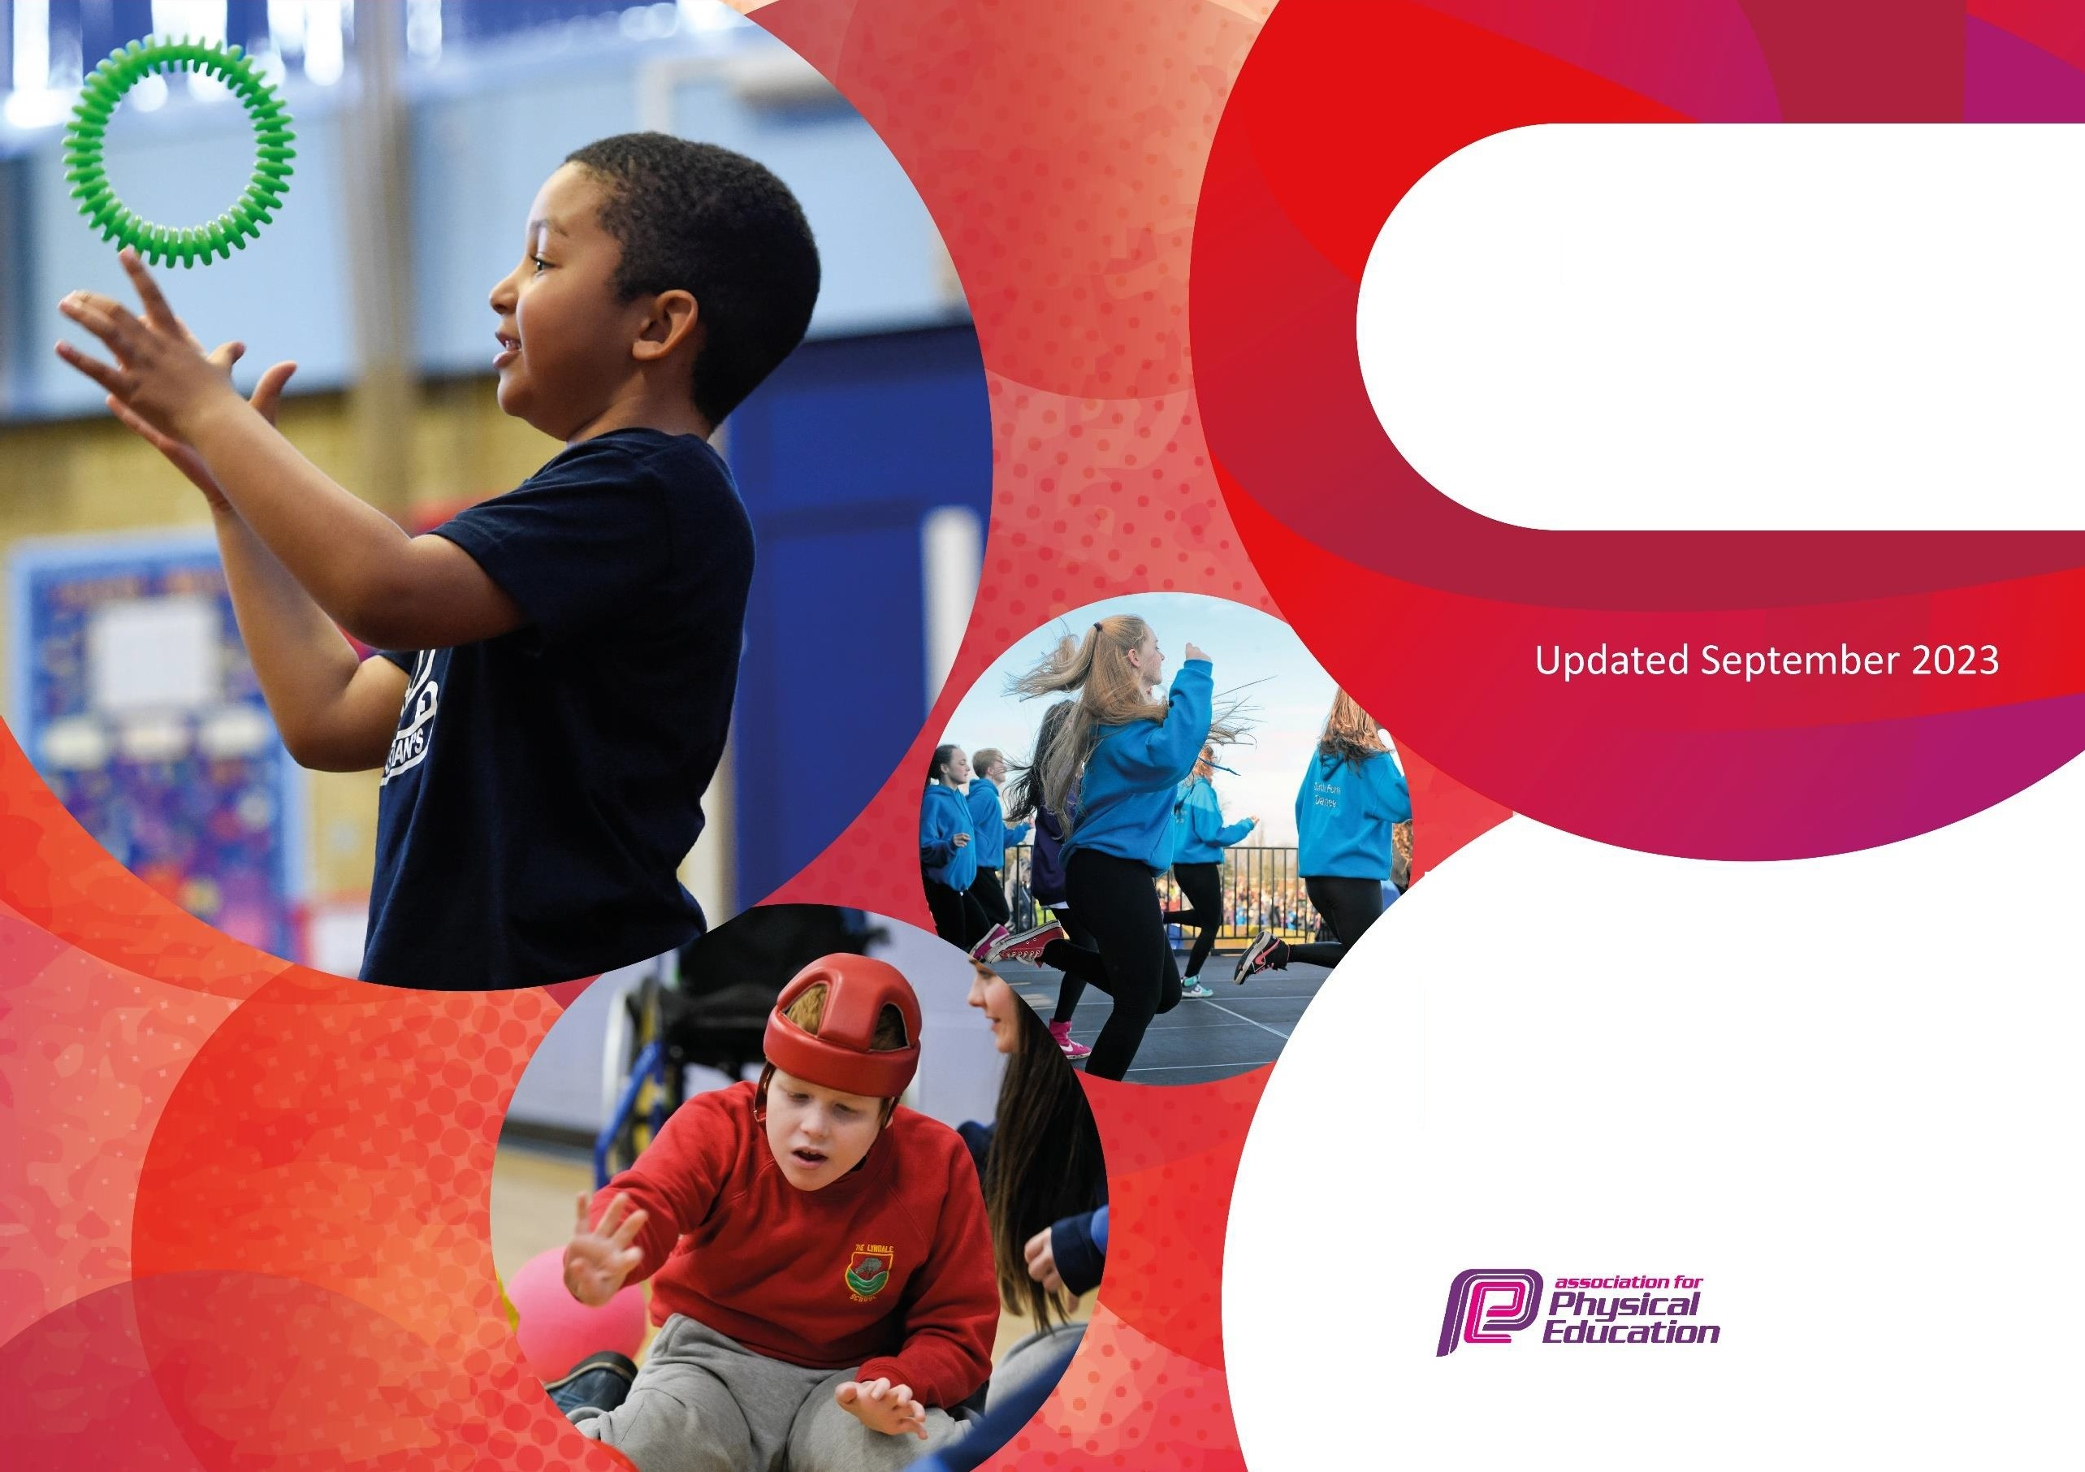
The Primary PE and sport premi•um
Planning, reporting and evaluating website tool

Commissioned by

Department for Education

Created by
- '111j YSOPOURTHT
'..JI • TRUST

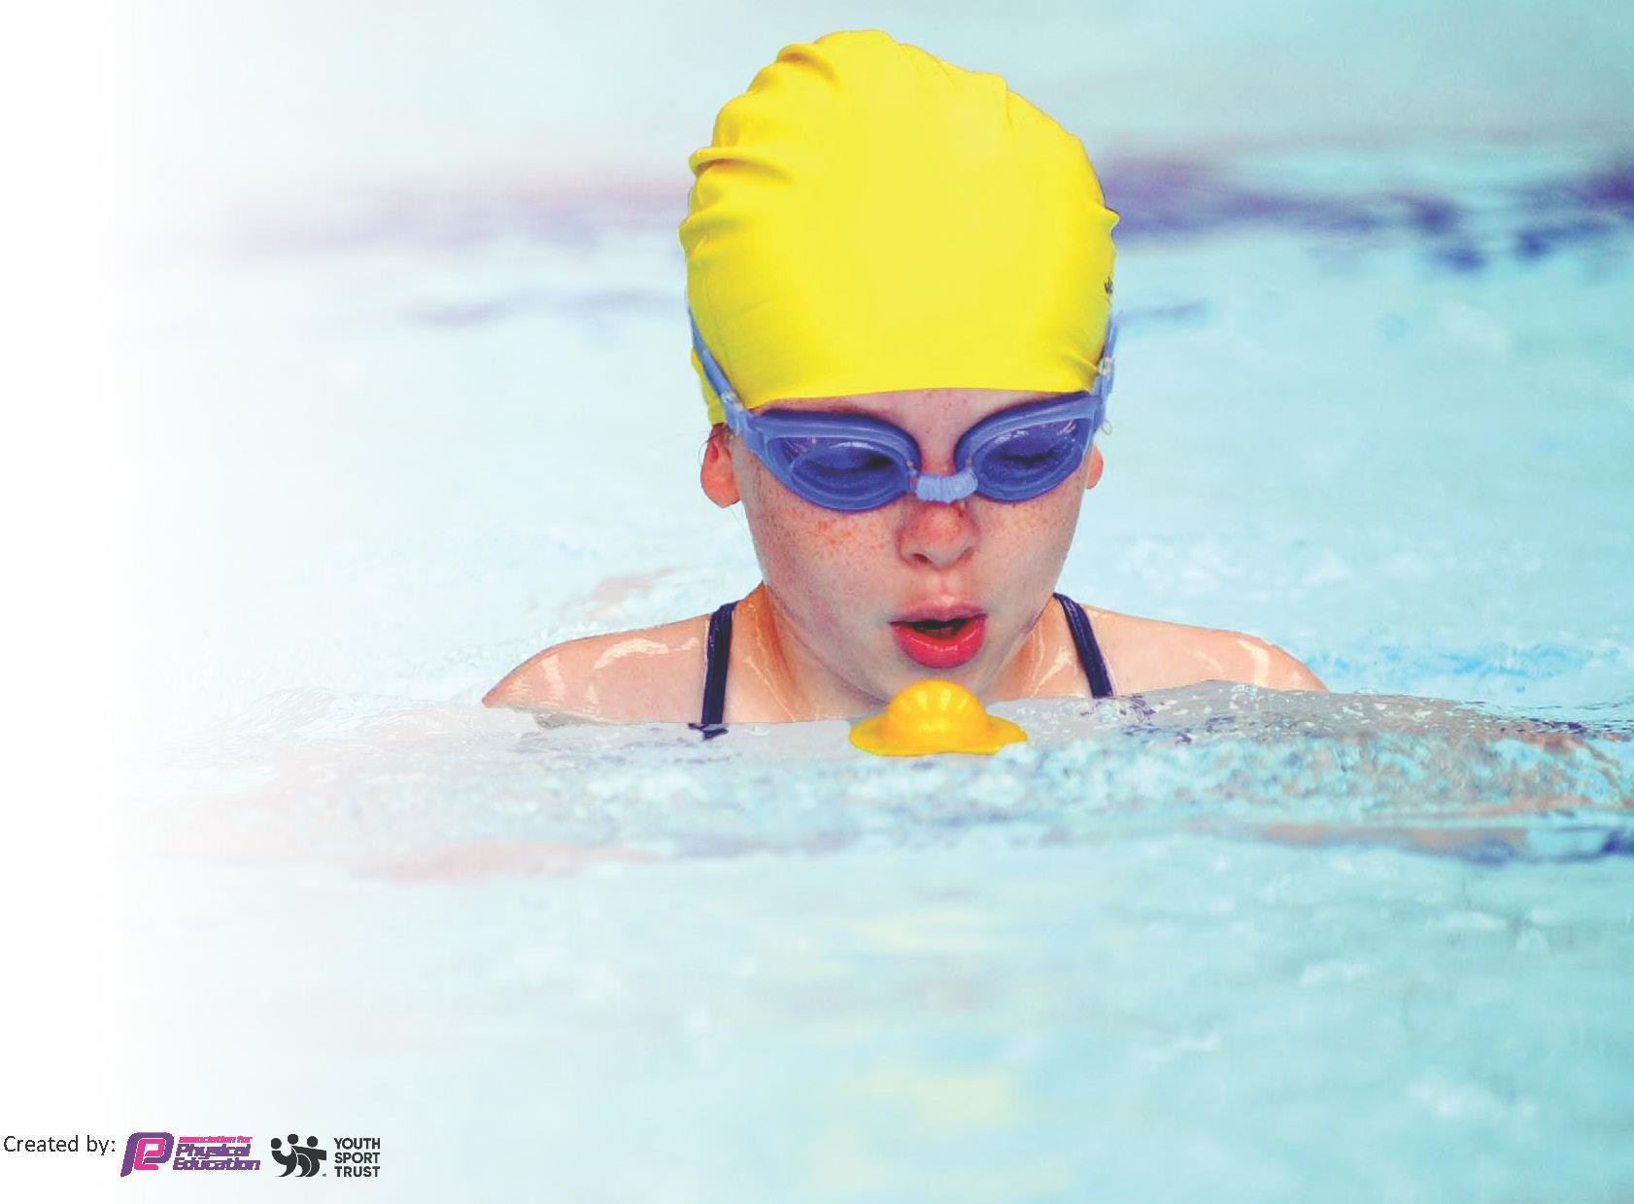
This template can be used for multiple purposes:
- It enables schools to effectively plan their use of the Primary PE and sport premium
- It helps schools to meet the requirements (as set out in guidance) to publish information on their Primary PE and sport premium
- It will be an effective document to support Ofsted inspections enabling schools to evidence progress in Physical Education (PE) and evidence swimming attainment, which forms part of the PE National Curriculum. We would recommend schools consider
the Intent, Implementation and Impact of any spend, as examined within the Education Inspection Framework.

It is important that your grant is used effectively and based on school need.

Schools must use the funding to make additional and sustainable
improvements to the quality of the PE, School Sport and Physical Activity (PESSPA)
they offer. This means that you should use the Primary PE and sport premium to:

- Build capacity and capability within the school to ensure that improvements made now will benefit pupils joining the school in future years
- Develop or add to the PESSPA activities that your school already offers.

The Primary PE and sport premium should not be used to fund capital spend projects; the school’s core budget should fund these. Further detail on capital expenditure can be found in the updated Primary PE and sport premium guidance.

The Primary PE and sport premium guidance, outlines 5 key priorities that funding should be used towards. It is not
Created by:


necessary that spending has to meet all the key priorities, you should select the priorities that you aim to use any funding towards.

Although completing this template is not a requirement for schools, schools are required to publish details of how they spend this funding. Schools must also outline what the impact this funding has had on pupils’ PE and sport participation and attainment and how any spending will be sustainable in the future. All funding must be spent by 31st July 2025.

The Department for Education has worked closely with the Association for Physical Education (afPE) and the Youth Sport Trust (YST) to develop this template and encourages schools to use it. This template is an effective way of meeting the reporting requirements of the Primary PE and sport premium.
Review of last year’s spend and key achievements (2024/2025)
We recommend you start by reflecting on the impact of current provision and reviewing your previous spend.

Activity/Action | Impact | Comments
Use specialist PE staff for delivery sports  Develop use of MUGA so that pupils have access all year round to a quality resource for multi sports.  Operate a range of extracurricular clubs.  Operate a range of lunchtime clubs, sports, games and activities.  Swimming – ensure school staff have accessed appropriate coaching training and / or use of paid pool based instructors. | Greater range of sports experienced by pupils and increased enjoyment and involvement.  Daily use for lunchtime sports sessions provides a minimum of 30 minutes available activity daily.  Increased number of pupils keen to participate due to a range of session content.  Children from all year groups (except EYFS) offered sports club opportunities, with consistently high take up.  See above re MUGA use. Clubs organised and operated at lunchtime by Subject Leader during autumn term.  Increased number of pupils leaving school having reached the expected standards. | Following signposting from specialist staff pupils have taken up a wider range of sports in own time.  Changes to sports support staff and lunchtime supervision impacted on the provision during spring and summer terms  Changes to sports support staff impacted on the provision during spring and summer terms. Clubs will be funded and in place for 25/26  See above for actions for 25/26  We pay for specialist teaching, coaching and lifeguard services from the

Weekly and half termly celebrations helping to raise awareness and the profile of sport in school, these include assemblies.  Sports Days and fundraisers such as sports relief help raise the profile of sport and healthy living in school. Use of sporting activities to support PTA fund raising (Colour Run 2).  Keeping Healthy is a focus within PSHE Jigsaw scheme.  Purchase of PE Planning scheme of lessons and provide access to all staff. | School team and individual performances are celebrated in assemblies and on the school newsletter, website, class dojo and social media.  Sports days and other events very well attended by families, with parents getting involved in helping with events and taking part in parts of sports day such as the parent race.  Recent Ofsted report highlighted that children know how to eat and act healthily for their own wellbeing.  Staff are more confident when delivering sessions and clear intent of delivery is evident in all lessons across the school. Pupils developing key skills and increased fitness. | local swimming pool. The Subject Leader and Class teacher oversee and accompany the group, both of whom hold appropriate qualifications.  Sports fundraising events are well attended by school community. Colour Run 2 had more participants than last year.

PE overview set up and disseminated to all staff at the start of the school year to ensure consistent provision and delivery.  Children in Y4 visit Peat Rigg to experience a range of outdoor pursuits including beck scrambling and canoeing.  Children across the school undertake visits and activities in the local and wider environment to broaden their experiences. These include beach visits/games, golf club, athletics facilities, visits to specialist community sports facilities.  Visit to school by Paralympian to inspire children to take part in non- conventional sports.  Children have participated in a range of intra and inter school competitions in sports such as football, athletics, cross country, rugby, netball, rounders and table tennis.  Purchase of an Orienteering scheme, markers and staff training. | Teachers feel more prepared for PE lesson delivery and more confident in a wider range of disciplines and events.  Children have successfully accessed OAA which cannot be delivered on site. They have experienced a range of pursuits previously unfamiliar with.  Taking part in inter-school sports competitions has inspired children to participate in sport and practice their skills, increasing participation at school and home.  Successful visit enjoyed by all the children. Linked to school community values  Increased number of events taken place with increased number of children attending and representing the school.  Ofsted commented on lack of OAA on site. Scheme designed to support sports, school values and outdoor pursuits. | Change of provider has ensured a wider range of activities and experience at a reduced cost.  Children proud to represent the school and well supported by parents.  Popular event and children supported fundraising. L  Platinum Sports Mark achieved 2024/25 for the 2nd successive year- following on from 3 consecutive years of Gold Sports Mark achievement.  Staff trained and orienteering used with cross curricular links. This is to be developed further and incorporated into whole school PE planning.

Key priorities and Planning
This planning template will allow schools to accurately plan their spending.

Action – what are you planning to do | Who does this action impact? | Key indicator to meet | Impacts and how sustainability will be achieved? | Cost linked to the action
Continued use of specialist PE providers such as golf, cricket and fitness to offer variety and additional experiences for pupils.  Consolidation of Cross Curricular Orienteering Programme and introduction of school club | Pupils, teachers.  Pupils, teachers | Key indicator 1 -The engagement of all pupils in regular physical activity – the Chief Medical Officer guidelines recommend that all children and young people aged 5 to 18 engage in at least 60 minutes of physical activity per day, of which 30 minutes should be in school.  Key indicator 4: Broader experience of a range of sports and activities offered to all pupils.  Key indicator 4: Broader experience of a range of sports and activities offered to all pupils.  Key indicator 3: Increased confidence, knowledge and skills of all staff in teaching PE and sport | More pupils meeting their daily physical activity goal, more pupils encouraged to take part in PE and Sport Activities.  Children will access on site OAA in planned curriculum entitlement and increase their knowledge base. Encourage pupils who do not necessarily enjoy traditional sports.  Cost of staff to run additional orienteering club | £5,300  £2000

Additional catch up swimming sessions for pupils who have not yet met the expected standard  Children in Y4 visit Peat Rigg Outdoor Education Centre to experience a range of outdoor pursuits including beck scrambling and canoeing.  Creation of OAA Learning Environment such as Forest School and Orienteering.  Continued profile raising of Sport in school, including aspirational achievements, attendance at friendly and competitive events and awareness / | Pupils, teachers, families  Pupils  Pupils, teachers  Pupils, teachers, families | Key indicator 1 -The engagement of all pupils in regular physical activity – the Chief Medical Officer guidelines recommend that all children and young people aged 5 to 18 engage in at least 60 minutes of physical activity per day, of which 30 minutes should be in school.  Key indicator 4: Broader experience of a range of sports and activities offered to all pupils.  Key indicator 4: Broader experience of a range of sports and activities offered to all pupils.  Key indicator 3: Increased confidence, knowledge and skills of all staff in teaching PE and sport  Key indicator 2: The profile of PESSPA being raised across the school as a tool for whole school improvement | Continued improvement to the number of children achieving the standard.  Greater enjoyment of swimming.  Children experience OAA in a different setting and enjoy activities not usually available in our locale.  Enabling children to more regularly access OAA on site. Staff to develop own skills and knowledge.  Increased involvement and numbers in sport and events where pupils represent the school.  Support of spectators at inter school events.  Involvement in celebrations | £1,200 (bus & hire fees)  £1,500 subsidy  £1,000 (new resources)  £3,500 (staffing, resources etc)

promotion of national and international sporting events.  Continued use of PE Planning Subscription  Provision of extra-curricular clubs to offer variety and additional experiences for pupils. | Pupils, teachers, subject leader  Pupils, teachers, subject leader | Key indicator 3: Increased confidence, knowledge and skills of all staff in teaching PE and sport  Key indicator 1 -The engagement of all pupils in regular physical activity – the Chief Medical Officer guidelines recommend that all children and young people aged 5 to 18 engage in at least 60 minutes of physical activity per day, of which 30 minutes should be in school.  Key indicator 4: Broader experience of a range of sports and activities offered to all pupils. | of achievements and sporting events.  Expand and improve provision and ensure consistency of delivery. Staff CPD.  More pupils meeting their daily physical activity goal, more pupils encouraged to take part in PE and Sport Activities. | £2,000  £1600 (staffing additional hours)

Key achievements 2024-2025
This template will be completed at the end of the academic year and will showcase the key achievements schools have made with their Primary PE and sport premium spending.

Activity/Action | Impact | Comments
Use of PE Planning  Attendance at inter school sports events  Sports events played against local schools  Introduction of orienteering scheme and staff training.  Achievement of Platinum Games Mark | Excellent provision throughout the year groups within the PE curriculum. LTP adapted to ensure broad range of sports. Teacher confidence increasing teaching PE.  Continued success at inter-school competitions  Opportunities for children to represent school in fixtures.  Increased opportunities for team work and communication with pupils displaying collaboration and leadership. Offered an alternative to traditional competitive sports, appealing to a broader range of pupils.  High profile of sport recognized. Criteria supports sports planning and provision against expected standard. | Look at LTP and assessments.  Further develop links and provide funding for staff to facilitate.  Embed this and establish as part of school sports and PD offer with inclusion of after school clubs and cross curricular learning.  Maintain this award 25/26

Swimming Data
Meeting National Curriculum requirements for swimming and water safety.
Priority should always be given to ensuring that pupils can perform safe self-rescue even if they do not fully meet the first two requirements of the National Curriculum programme of study

Question | Stats: | Further context  Relative to local challenges
What percentage of your current Year 6 cohort can swim competently, confidently and proficiently over a distance of at least 25 metres? | 85.71% | Improved on last year (+9.1%) due to offering additional top up sessions for Year 5 and 6 pupils who have not yet reached the expected standard.
What percentage of your current Year 6 cohort can use a range of strokes effectively [for example, front crawl, backstroke, and breaststroke]? | 87% | Even though not all children can reach the 25m mark they are able to use a range of different strokes to get close to this.

What percentage of your current Year 6 cohort are able to perform safe self-rescue in different water-based situations? | 86% | Not undertaken as part of our specific scheme of work.
If your schools swimming data is below national expectation, you can choose to use the Primary PE and sport premium to provide additional top-up sessions for those pupils that did not meet National Curriculum requirements after the completion of core lessons. Have you done this? | Yes
Have you provided CPD to improve the knowledge and confidence of staff to be able to teach swimming and water safety? | No | We purchase lifeguard and teaching services from the swimming pool as part of our bookings.

Signed off by:

Head Teacher: Gavin Dyer | G Dyer
Subject Leader or the individual responsible for the Primary PE and sport premium:  Miss A Hillion– Subject Leader | A Hillion
Governor: Abigail Combes (IEB Chair) | A Combes
Date: 15.7.2025 | Next update: July 2026

