**Extreme Earth**

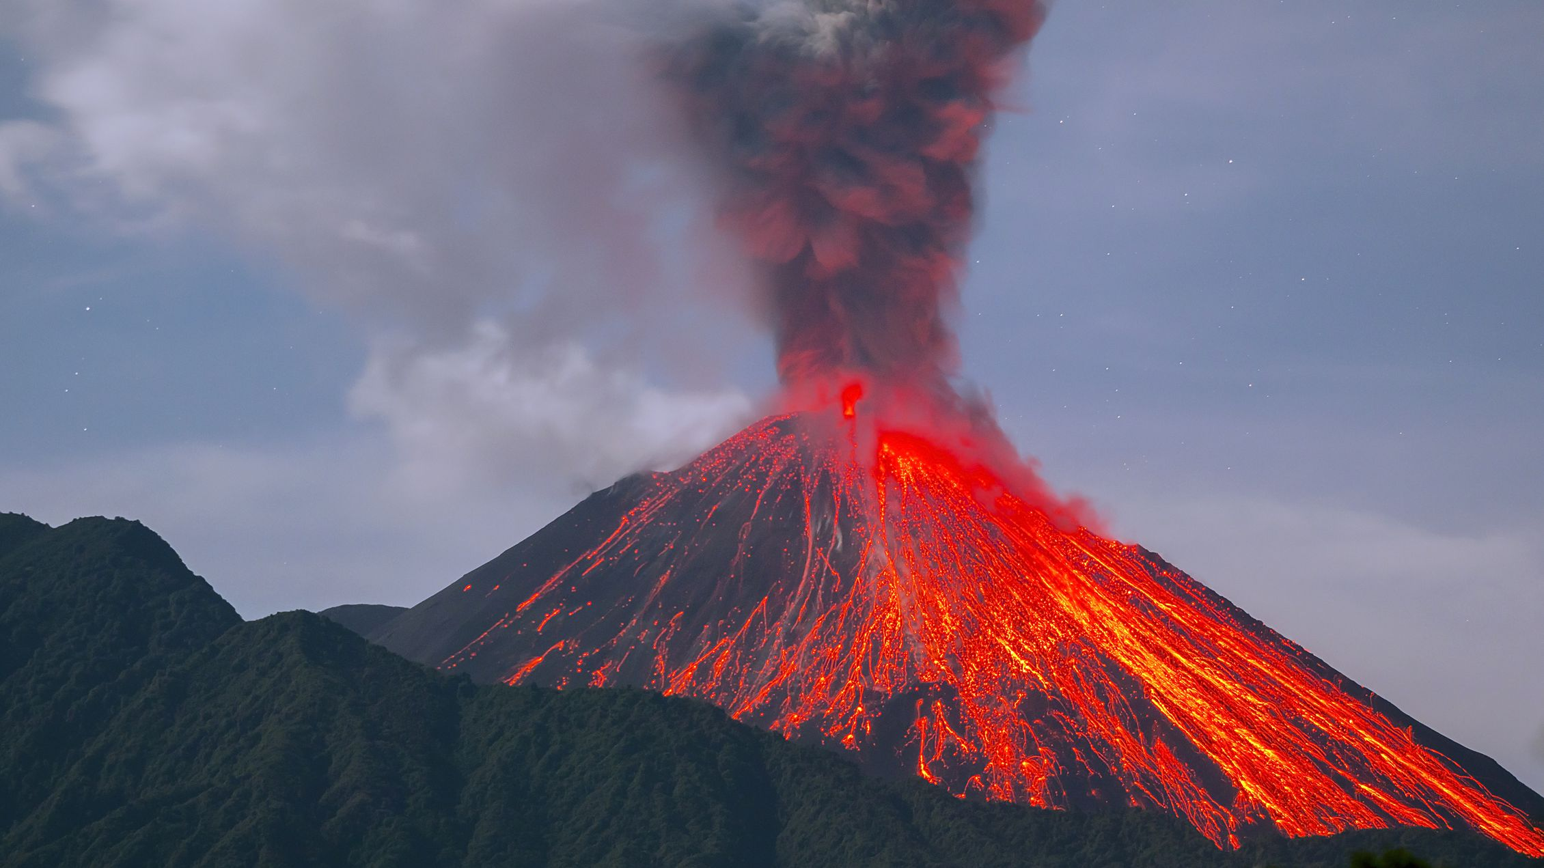

**Design Technology**

How can I develop an earthquake resistant building?

**Science**

Careful observation, observation over time and secondary research.

Properties of liquids and non-Newtonian liquids.

What is friction?

**A Caring Community**

What can we do in our local environment to help preserve the planet?

**Locality & Environment**

Create sculptures of a volcano on the beach.

**Music**

Learn the volcano song to help with the eruption process.

Pitch: rounds and scales.

**Art**

Inspired by the works of Kate Fortin. Create acrylic representations of erupted volcanoes.

**Computing**

Computing systems and networks – Communication.

**Geography**

What are plate tectonics and continental drift?

What are the different types of plate boundaries?

How to describe the different features of volcanoes.

What are the stages of a volcanic eruption?

What are climate zones and how do they affect growth?

How do Earthquakes happen?

**Wheatcroft Community Primary School**

**Year 6 Autumn 1**

**Curriculum enhancements**: Beach school – Create a beach sculpture of a volcano.

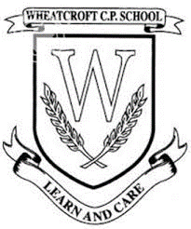

**History**

What happened to Pompeii when Mount Vesuvius erupted in 79 AD?

**English (Class Reader)**

Reading: The Girl of Ink and Stars, The Last Bear, Letters of Pliny the Younger.

Writing: Whole School writing – Change Sings

The Last Bear

Letters to the citizens of Pompeii.

**Cross-curricular maths**

Using grid references in map work.

Creating graphs to record science results.

**French**

Les portraits

**PE**

 Tag rugby and football.

**RE**

 U2.5 Is it better to express your beliefs in arts and architecture or in charity and generosity?

**PSHE**

 Being Me in My World