SPaG.com guide.
Head over to this website…
https://www.spag.com/Public/Home

Once you are on the website, log in by clicking the button at the top-right corner highlighted in blue the image below.

Once you have logged in, any open tests will be displayed as the image below shows. The homework set for the children will appear in the Live Tests section and any previous tests they have done will appear in the Finished Tests section.
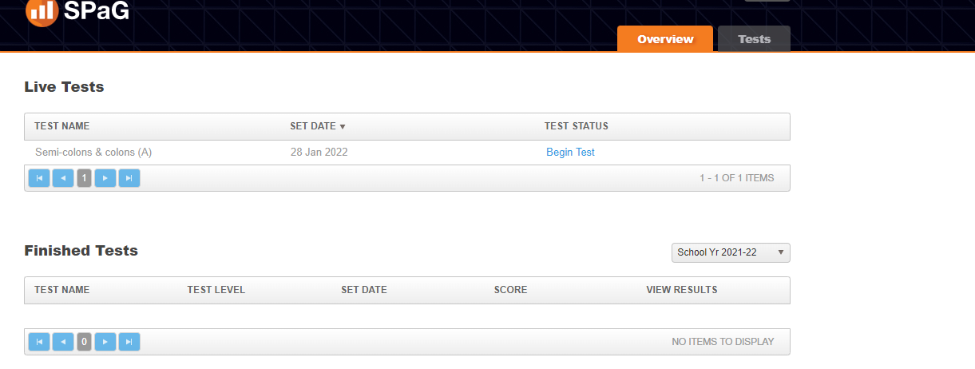
After the children have completed a test, it is really important that they look on the view results section, as this will explain to them how to improve on the questions that they didn’t answer correctly.

