**Victorian Scarborough**

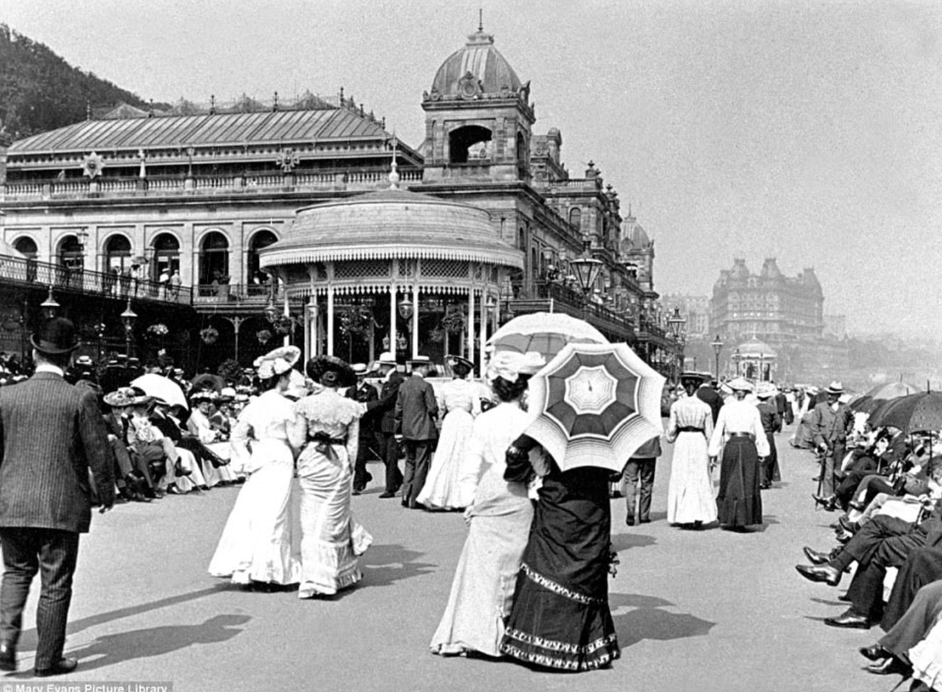

**Geography**

Human geography – types of settlement

Identify countries belonging to the British Empire, using maps, atlases and globes.

4 Figure Grid References

**Science**

**Materials**:

Sorting and classifying according to properties and use.

Properties of materials, including their hardness, solubility, transparency, conductivity (electrical and thermal), and response to magnets and their uses in everyday life.

**Levers, Pulleys & Gears**

Mechanisms, including levers, pulleys and gears, allow a smaller force to have a greater effect

**A Caring Community**

Use of our school community as a basis for art work. Link to our wider community and how the Victorians have influenced our town. Caring for our community to preserve history of our town.

**Locality & Environment**

Spa Waters, Art Gallery – recreate painting, Blue Plaques, Spa Foot Bridge – segregation/toll bridge, Grand hotel, cliff lift, water chute open air theatre, Scarborough Maritime museum, Castle Museum York, Beck Isle Museum,

Harbour Bar Pasteuriser – Louis Pasteur

**Music**

Pulse- Victorian songs – At the mill

Musical elements-performing together

**Art**

William Morris art work – study art work, take photos of nature and then use photos to re-create William Morris style art work.

Art gallery trip-Victorian Scarborough paintings

**Computing**

Online Safety

Programming

**Design Technology**

Victorian Toys-focus on cams

**Wheatcroft Community Primary School**

**Year 5 Victorian Scarborough** Autumn 1 and 2

**Curriculum enhancements**: Visit to Spa Bridge, Spa Water, Grand Hotel, Scarborough Art Gallery, Victorian Day.

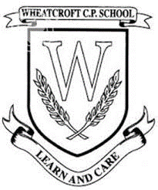

**History**

When was the Victorian period? The British Empire under Queen Victoria.

What significant changes happened during this time?

Victorian Legacy

Local History

What was it like for children living in Victorian Scarborough?

Lower, middle and upper classes

Schooling, clothes, work, toys, money

Tourism, spa waters, railway, jobs,

**English**

**Class Reader** The Street Child, Cogheart, The Nowhere Emporium

**Narrative:**

*Descriptive writing* – a Victorian Scene

*Story Writing* – Victorian themed

*Diary* – Child in the Workhouse e.g.Jim from Street Child

Or a day in the life of a Victorian schoolchild from lower, middle or upper class

**Poetry**

Christmas poetry

**Non-Fiction**

*Information Text* – Life in Victorian Scarborough – Spa Waters, Tourism, Railway, Jobs, Buildings

*Persuasion* – Come to Scarborough, Drink the Spa Waters

*Discussion*- For/against child labour from Victorian point of view

*Explanation*– How the Cliff Lift works/How the Harbour Bridge works

**French**

Ma famille

**PE**

 Football, Rugby

**RE**

 Why do some people think God exists?

If God is everywhere, why go to a place of worship?

**PSHE**

 Jigsaw-Being Me