**Music**

Exploring sound sources

**Out Of This World**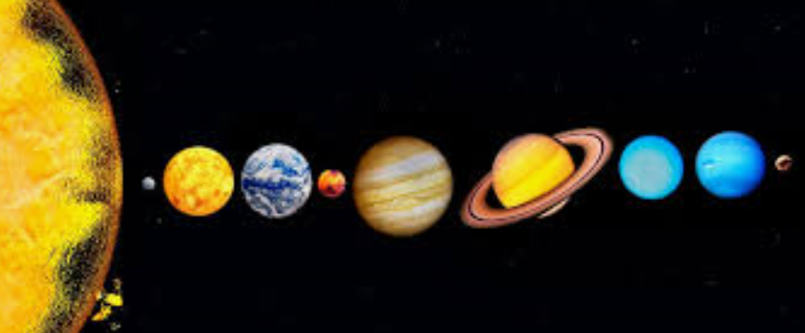

**Science**

What are the names of the planets?

What shape are the planets how do we know?

How did the universe begin?

Where is our planet in relation to the rest of the solar system?

Why do we have day and night?

What causes our seasons?

Why don’t we float away?

What is it like to be in space?

Investigations:

Water Resistance

Friction

**A Caring Community**

Link to RE and how we can help our community as Jesus helped his.

**Locality & Environment**

Scarborough Astronomical Society

Space station sightings

Moon diary

**Music**

Holst – The Planets

**Art**

Peter Thorpe artist – study the work that he has done. What is different about it? (abstract background with space theme picture on top)

Study different pictures then select one to re-create onto canvas using acrylic paint. Step by step process. Create class art gallery.

**Computing**

Programming

**Wheatcroft Community Primary School**

**Year 5 Spring 1**

**Curriculum enhancements**: Moon Watch, Scarborough Astronomical Society, National Space Centre website, STEM centre

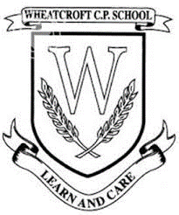

**English (Class Reader)**

**Reading:** Class Novel –Cosmic, War of the Worlds, Curiosity

Range of non-fiction books. Neil Armstrong, Tim Peake Factfiles

**Writing:**

Narrative: Diary writing, space poetry

Non-Fiction: Explanation text about a new rover (Curiosity)

Poetry: Star Seeker

**Maths**

Multiplication & Division

Fractions

**French**

Cher Zoo

**PE**

 Zumba & Gymnastics

**RE**

 What Would Jesus Do? Can we live the values of Jesus in the 21st century?

**PSHE**

Dreams & Goals