**Walk like an Egyptian**

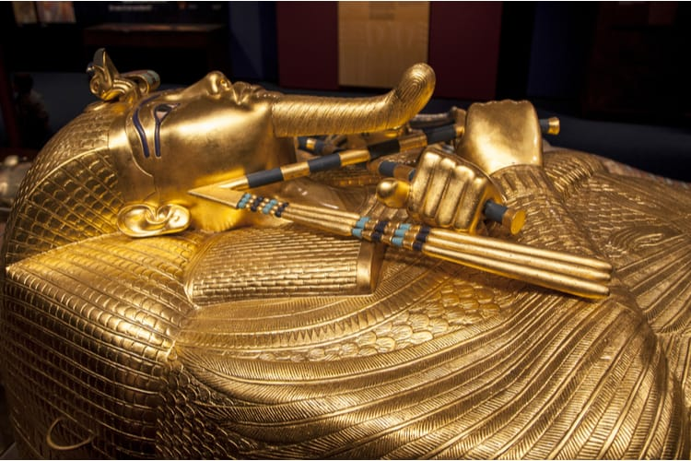

**Design Technology**

Making papyrus.

Designing and making canopic jars.

Designing and making pyramids.

Making saboob (Egyptian flatbread)

**Science**

How do the organs of the human body work?

The function of the body’s organs and the circulatory system.

Nourishing plants – How does river flooding aid this?

How does light travel?

**A Caring Community**

Local Egyptologist, Lauren Bruce, visiting children in school.

**Locality & Environment**

Papyrus reed gates at the Esplanade.

**Music**

African songs – rhythm and pulse.

Teddy Davis – Tutankhamun Song

Gold everywhere – Tutankhamun Song

**Art**

Designing and making canopic jars.

Designing and making pyramids.

Ancient Egyptian portraits.

**Computing**

Programming A – Variables in games

**Geography**

The Valley of the Kings – eight points of a compass.

Exploration of the River Nile and how this facilitates life.

Developing river vocabulary.

Irrigation and farming.

Distribution of resources

**Wheatcroft Community Primary School**

**Year Six Spring one/two**

**Curriculum enhancements**: Visit to Esplanade papyrus gates. Ancient Egyptian artefacts in school. Visit the Ancient Egyptian exhibition at the British Museum in London.

Visitor into school – Lauren Bruce (Egyptologist).

**History**

Who is Tutankhamun and how did Howard Carter increase his fame?

What is the Rosetta stone?

What are canopic jars?

Why was the burial process sacred?

The mummification process.

**English (Class Reader)**

Reading: Secrets of a Sun King.

Writing:

* Information text – The discovery of Tutankhamun.
* Explanation text – How to mummify a pharaoh.
* Narrative myths – Tales of the Gods: Ra.

**Cross-curricular maths**

Timelines.

Ratio for embalming.

Comparing weight of organs.

Using position, direction and angles to manipulate light.

**French**

Les carnaval des animaux

**PE**

 Gymmastics and Zumba

**RE**

U2.7 – What matters to Christians and humanists?

**PSHE**

 Dreams and goals